**Report -> for Physical Training Labs**

Contents

Digital tool ASIC flow 3

How to talk computer 3

Open-source digital ASIC Flow 3

RTL to GDS Flow 4

Open Lane flow 4

Run Synthesis full design picorv32a 5

Run Floor Planning for full design picorv32a 6

Results file and open in layout and see design after floorplaing 6

Placement of full design picorv32a 7

Cloning of standard cell (buffer) 8

Open buffer in standard cell 8

See the connections and cell layout after deleting the Geoms: 8

Run extraction for the buffer 9

Run SPICE for the buffer 9

Calculate rise transition and fall transitions from waveforms 10

Creating LEF for the Buffer 10

Add standard cell buffer inside the design picorv32a 11

Buffer added successfully inside the design 12

Created pre_sta.config and run sta and replaces the cells to reduce the slack value 12

Optimize synthesis to reduce the setup violations: 13

clock tree synthesis 15

clock tree routing and buffering using H-Tree algorithms 15

Clock net shielding and cross talk. 16

Genrate verilog after doing the replacement of the cells and run synthesis again 16

Run floorplan and placement with using modified Verilog netlist 16

Run CTS with using modified Verilog and after CTS new Verilog netlist DEF files has been created , Analysis the results 17

Setup timing analysis using real clocks 18

Post CTS analysis in tool openroad: 19

Setup and hold before editing the list: CTS_CLK_BUFFER_LIST 19

**Setup and hold after editing the list: CTS_CLK_BUFFER_LIST** 20

Insert the buffer in list CTS_CLK_BUFFER_LIST 20

Build power distribution network 20

Run routing 20

Final outputs after run routing : 21

Two steps for the routing 21

Feature of the TritonRoute 21

Inter-guide connectivity 22

Problems statement: 22

How to handle connectivity: 22

Final file list post-route 23

Post route STA Analysis 23

**Summary of the commands used:**

|  |
| --- |
| docker  ./flow.tcl -interactive  package require openlane 0.9  prep -design picorv32a  run_synthesis  init_floorplan  place_io  global_placement  tap_decap_or  detailed_placement  running pre sta -> sta pre_sta.config  run_pdn  run_routing |

# Digital tool ASIC flow

## How to talk computer

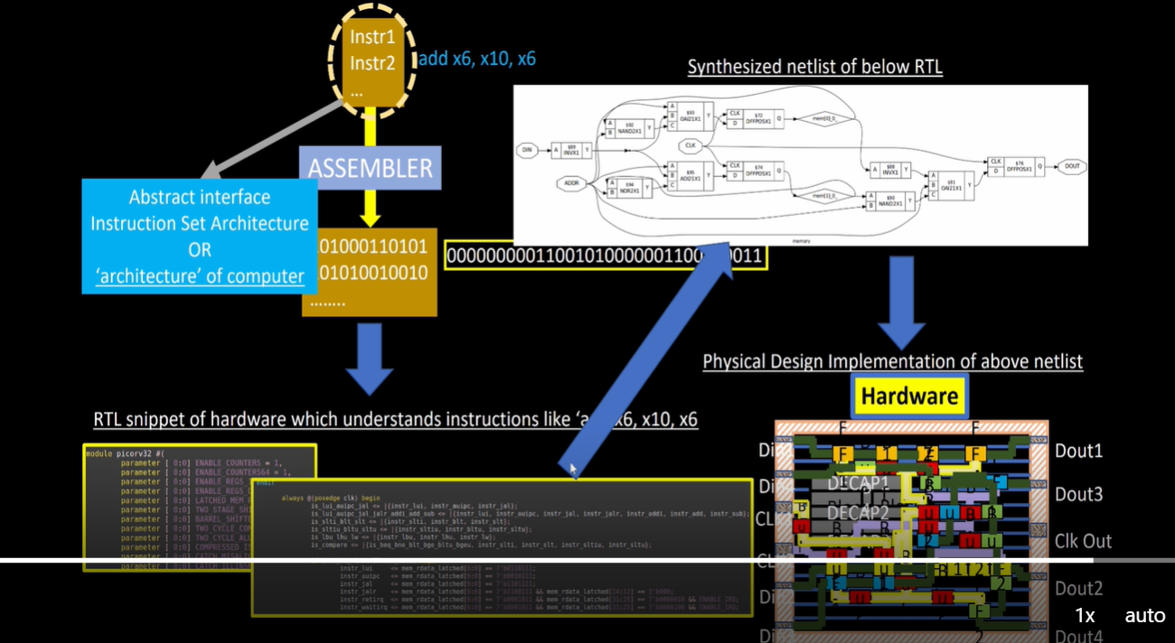

## Open-source digital ASIC Flow

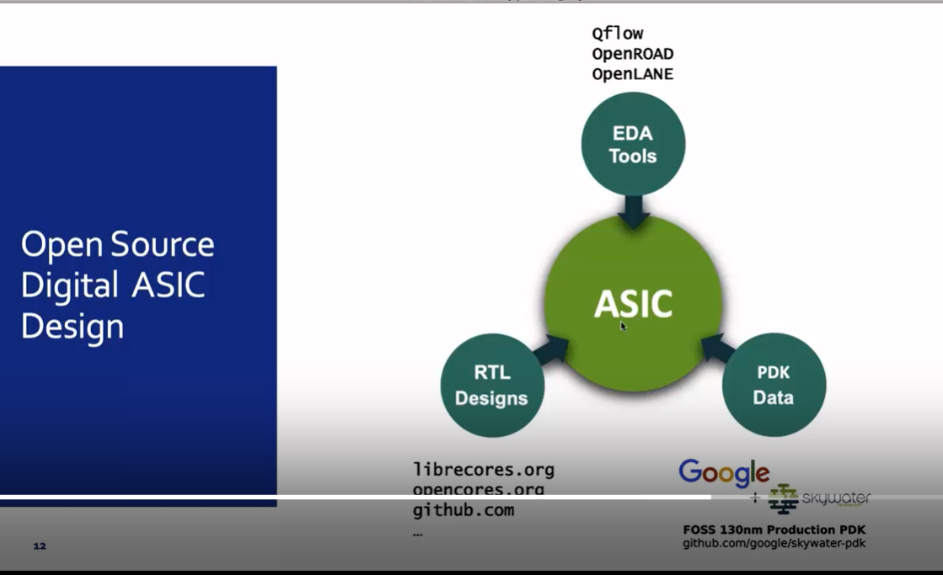

## RTL to GDS Flow

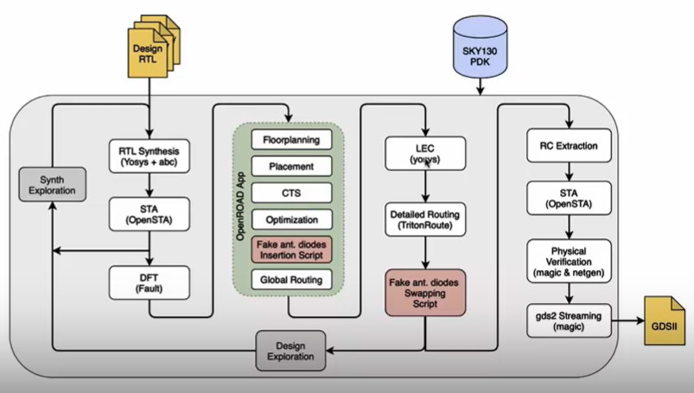

# Open Lane flow

Design Name: picorv32a:

/home/kunalg123/Desktop/work/tools/openlane_working_dir/pdks/sky130A/libs.ref/sky130_fd_sc_hd

Directory presents inside this:

cdl doc gds lef lib mag maglef spice techlef Verilog

**Design Preparation:**

Example for config.tcl

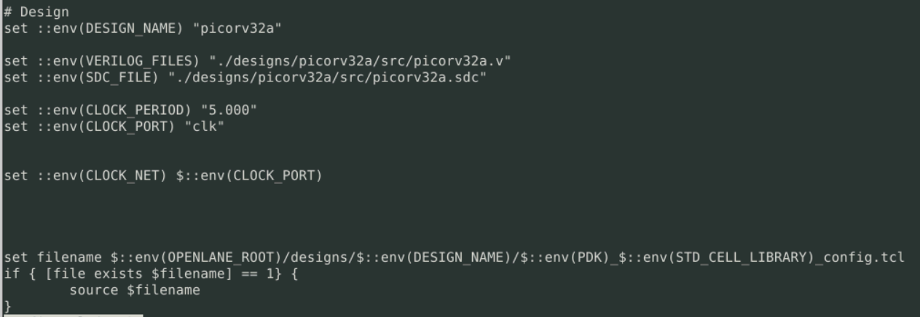

**Command to preparation data:**

./flow.tcl -interactive

prep -design picorv32a : merging the LEF

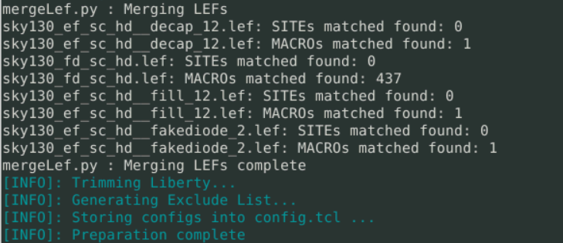

# Run Synthesis full design picorv32a

**Command used -> Run_synthesis**

**Results:**

Summary of synthesis and Flop ratio =10%

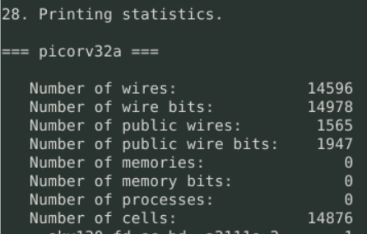

Files created after synthesis.



.v file and mapping has been done in synthesis stage:

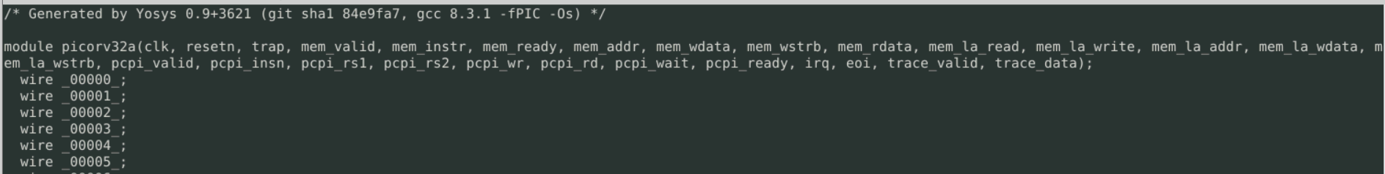

Report files:

nawal.kishor@ansys-pd-workshop-01:~/Desktop/work/tools/openlane_working_dir/openlane/designs/picorv32a/runs/24-06_11-06/reports/synthesis$ ls

1-yosys_4.chk.rpt 1-yosys_dff.stat 2-opensta.min_max.rpt 2-opensta.slew.rpt 2-opensta_tns.rpt

1-yosys_4.stat.rpt 1-yosys_pre.stat 2-opensta.rpt 2-opensta.timing.rpt 2-opensta_wns.rpt

# Run Floor Planning for full design picorv32a

Inside README file there is all command are given for all stages and set parameters based on that.  
**Example:** 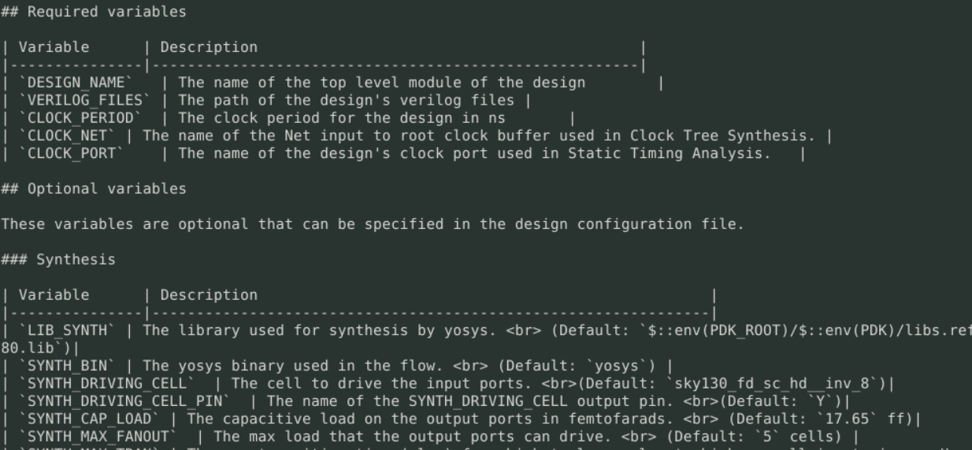

Priorities for the config files. Default config -> design config.tcl -> hdk .config.tcl

## Results file and open in layout and see design after floorplaing



Layout seen:

Open Layout in magic and query inside the GUI:

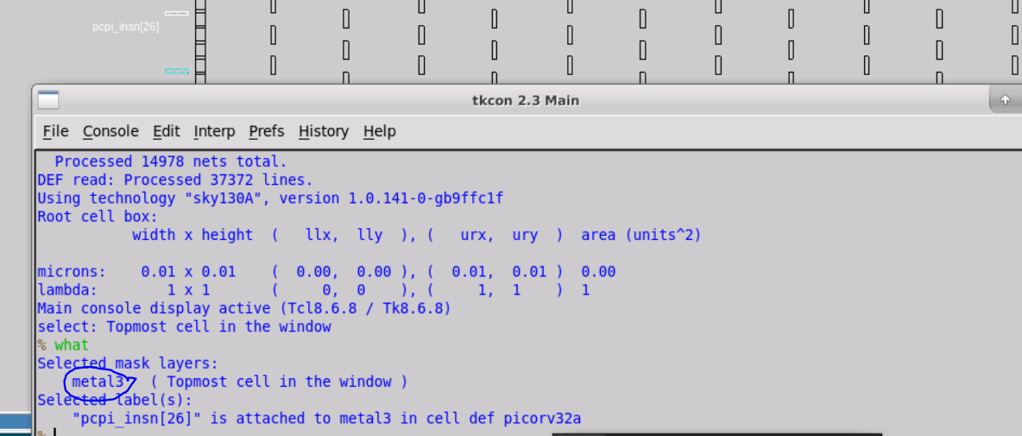

Standard cell placed at the lower side of the LEF.

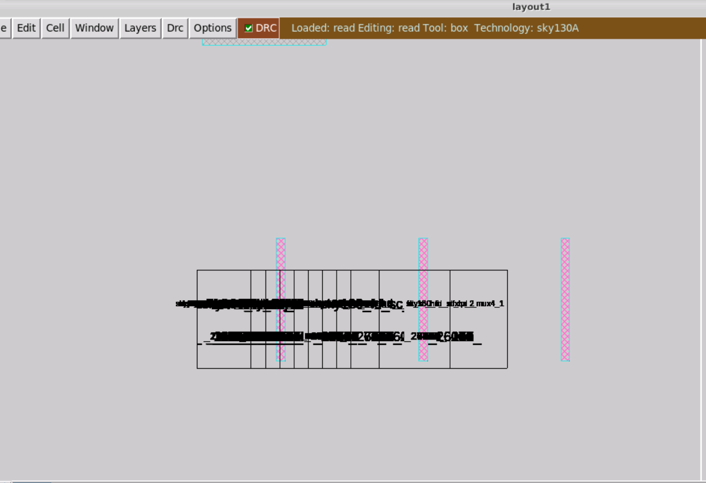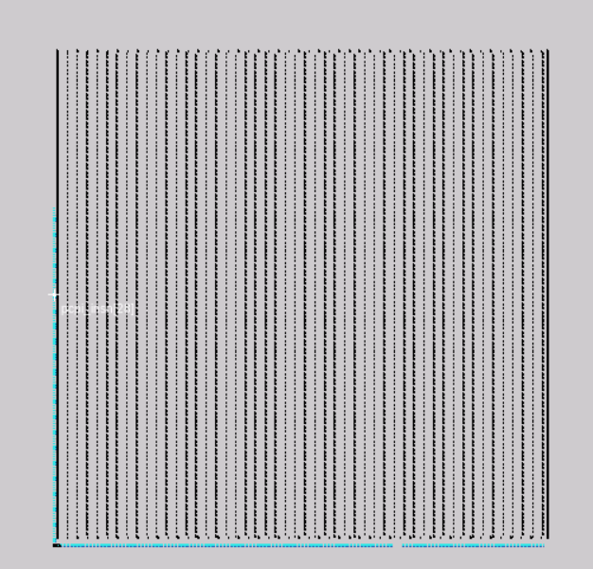

Can change the floorplan and any stage by changing the variable:

# Placement of full design picorv32a

Command used for to open layout in magic:



GUI design after placement: Standard cells are placed and without DRC rule checks.

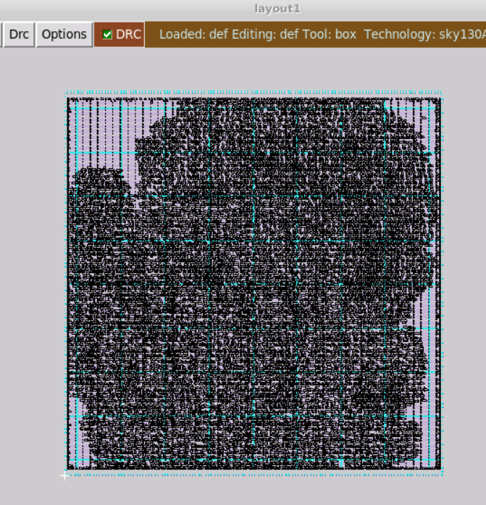 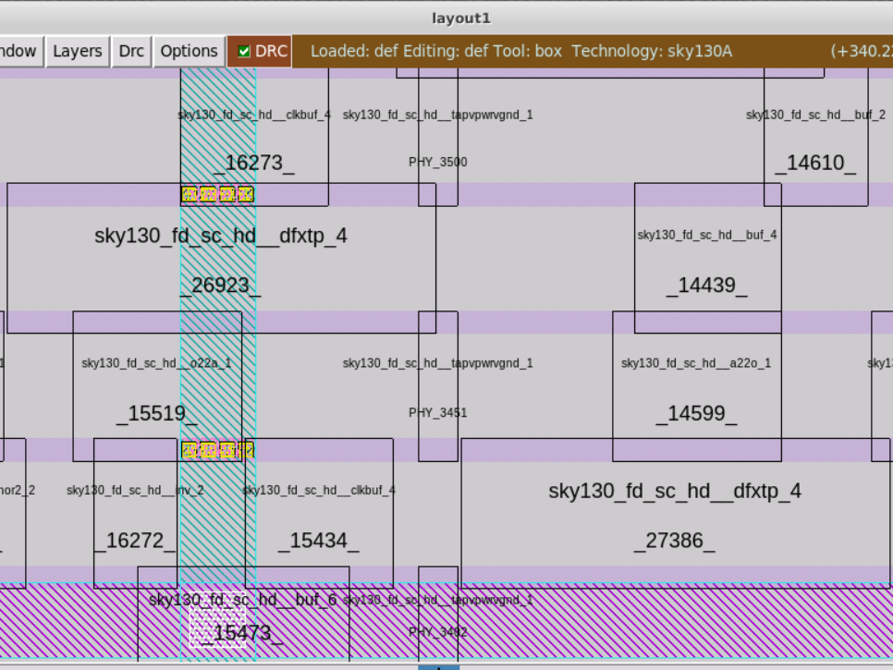

# Cloning of standard cell (buffer)

## Open buffer in standard cell

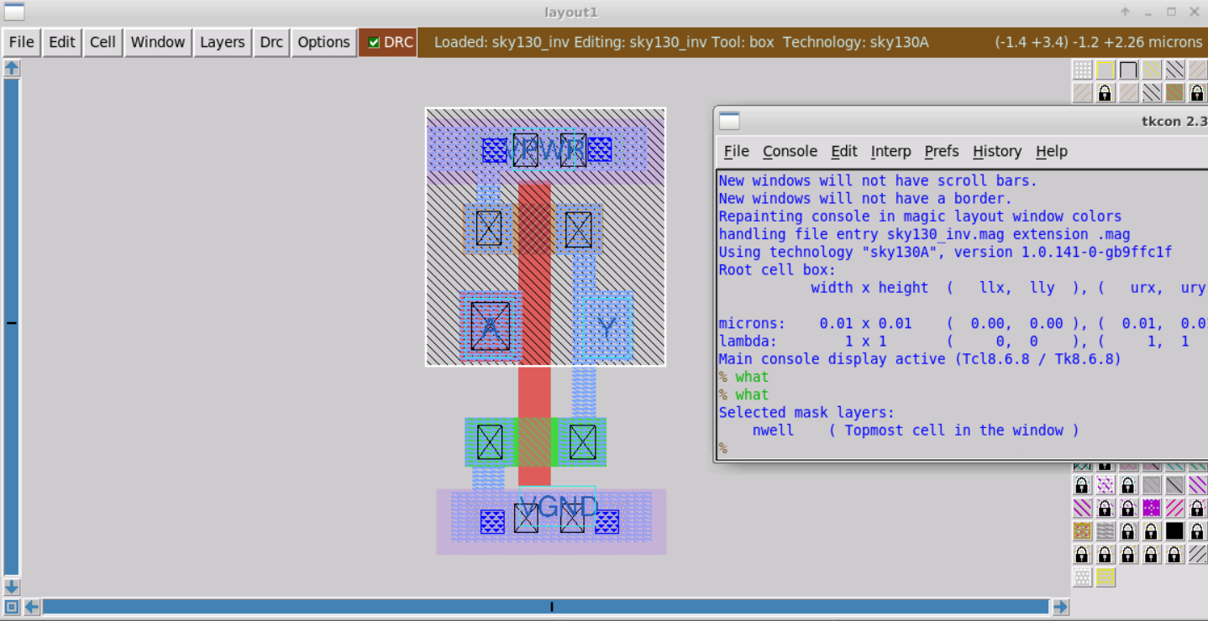

## See the connections and cell layout after deleting the Geoms:

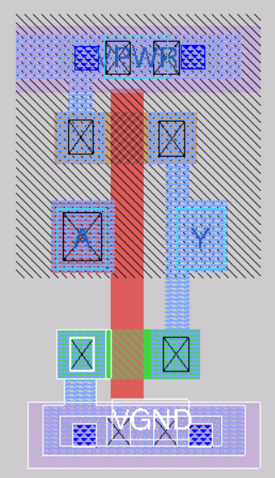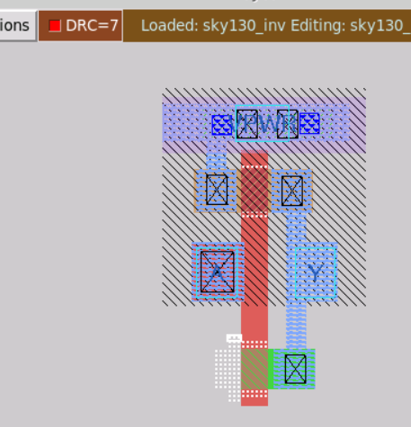

## Run extraction for the buffer

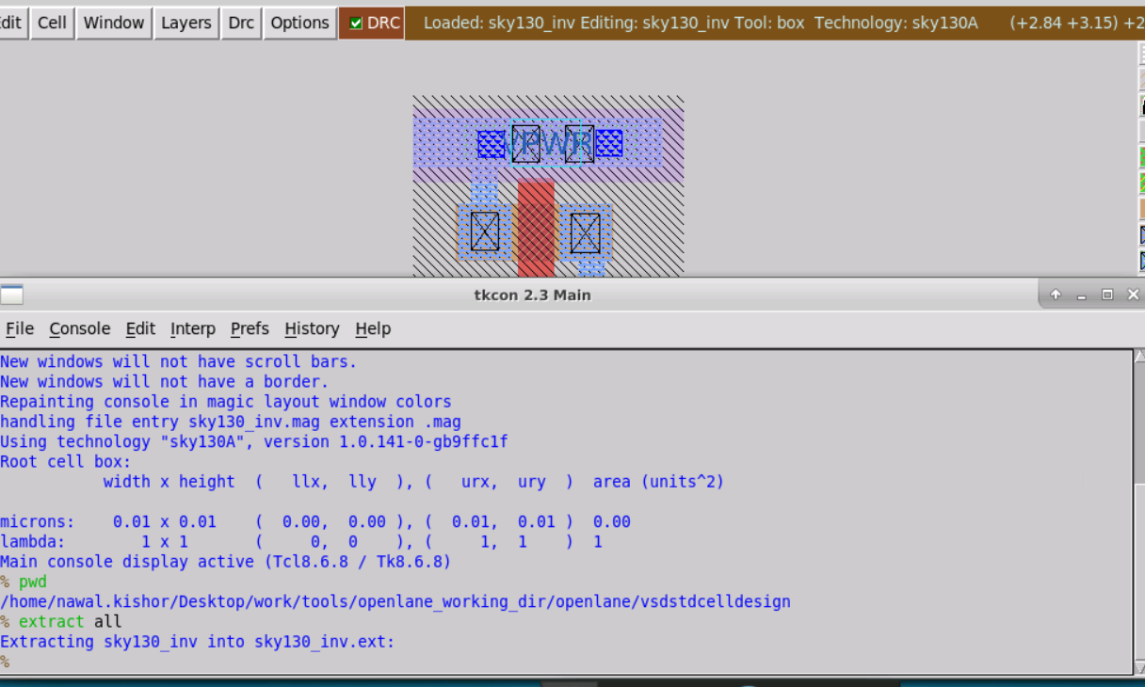

## Run SPICE for the buffer

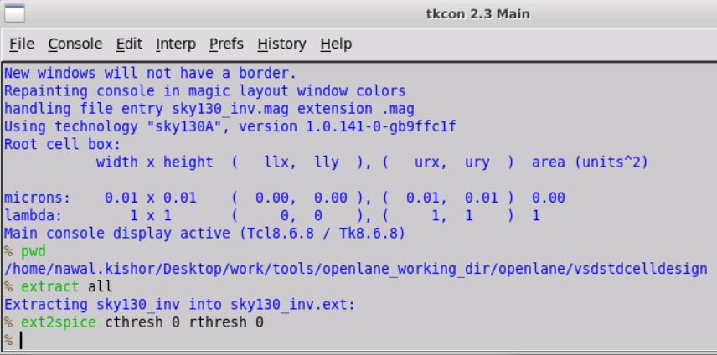

Command: extspice

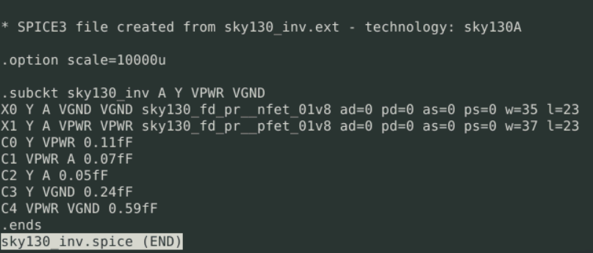

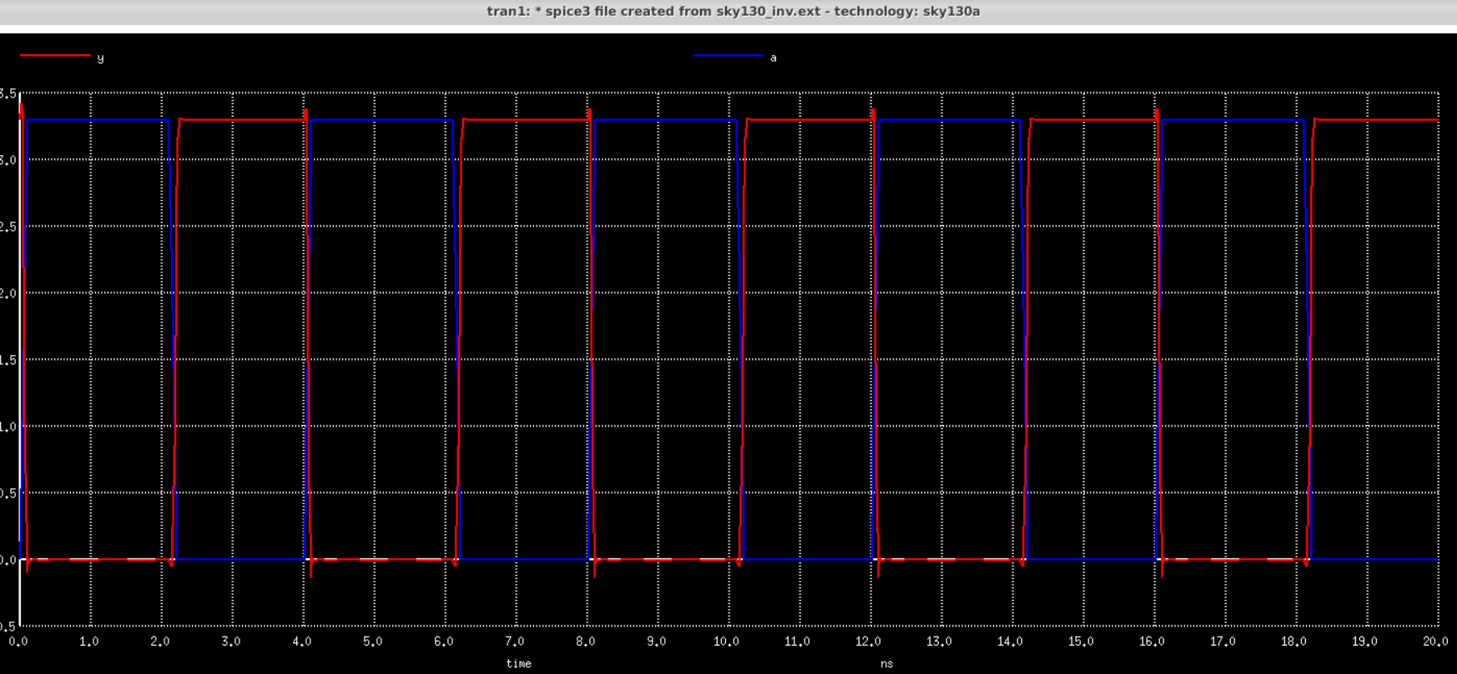

## Calculate rise transition and fall transitions from waveforms

**Rise transition: 0.5e-09 similarly can calculate the fall transition**

x0 = 2.23704e-09, y0 = 2.60161

x0 = 2.18134e-09, y0 = 0.659574

## Creating LEF for the Buffer

created the LEF file command used : lef write   
/home/nawal.kishor/Desktop/work/tools/openlane_working_dir/openlane/vsdstdcelldesign/sky130_vsdinv.lef

## Add standard cell buffer inside the design picorv32a

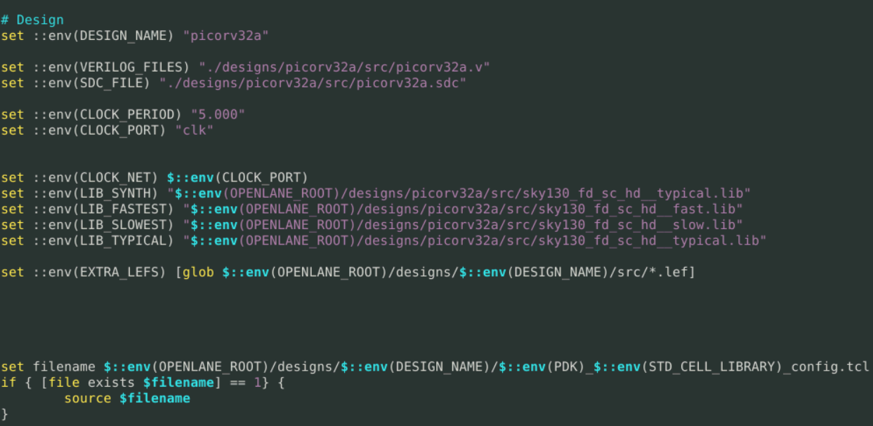

If a new custom cell needs to be plugged into openlane flow, include the lefs (the one extracted in [Step-5](https://github.com/nickson-jose/vsdstdcelldesign#defining-lef-properties-and-extracting-lef-file)) as below:

* In the design's config.tcl file add the below line to point to the lef location which is required during spice extraction.
* set ::env(EXTRA_LEFS) [glob $::env(OPENLANE_ROOT)/designs/$::env(DESIGN_NAME)/src/*.lef]
* Include the below command to include the additional lef into the flow:
* set lefs [glob $::env(DESIGN_DIR)/src/*.lef]

add_lefs -src $lefs

After synthesis

tns -711.59

wns -23.8

Chip area for module '\picorv32a': 147712.918400

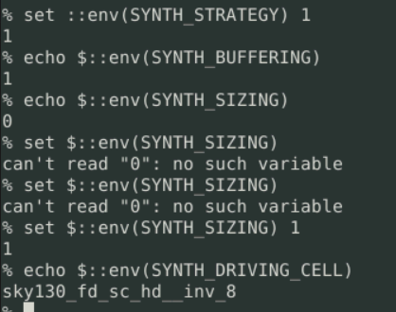

## Buffer added successfully inside the design

Command used:

run_synthesis

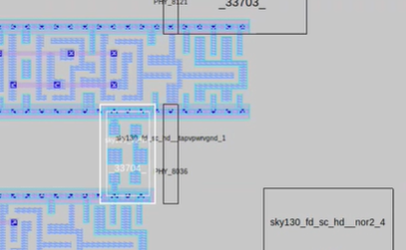

## Created pre_sta.config and run sta and replaces the cells to reduce the slack value

Command used: sta pre_sta.config

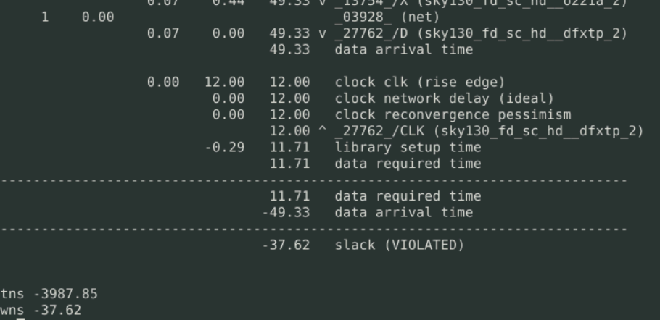

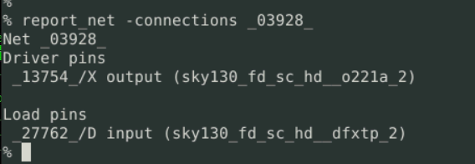

## Optimize synthesis to reduce the setup violations:

1. **By replacing the cells for the instance.**

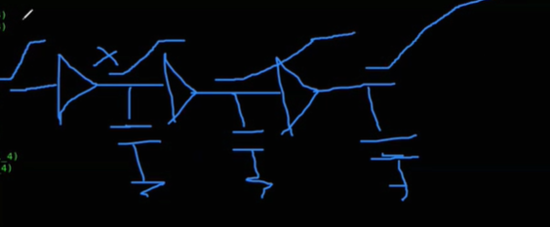

**Tws and tns differences after replacing the cell:**

**Without cell replacement:**

% report_net -connections irq_pending[0]

Net irq_pending[0]

Driver pins

**_51704_/**Q output (sky130_fd_sc_hd__dfxtp_2)

Load pins

_25870_/A input (sky130_vsdinv)

_27806_/A input (sky130_fd_sc_hd__buf_1)

_50554_/A1 input (sky130_fd_sc_hd__mux2_1)

_50801_/A1 input (sky130_fd_sc_hd__mux2_1)

**tns -3628.08**

**wns -34.78**

**After doing many replacements getting this slack**

% report_tns

tns -3602.71

% report_wns

wns -34.01

**tns and wns values changes with replacing the cell:**

command used:

% replace_cell _51704_ sky130_fd_sc_hd__dfxtp_1

% report_checks -fields {slew trans net cap input_pin}

% report_tns

tns -3628.33

% report_wns

wns -34.78

**tns and wns values changes with command:**

% replace_cell _51704_ sky130_fd_sc_hd__dfxtp_4

% report_checks -path_delay min_max -fields {slew trans net cap input_pin}

% report_tns

tns -3630.09

% report_wns

wns -34.81

# clock tree synthesis

## clock tree routing and buffering using H-Tree algorithms

we use buffer repeater to reduce the jitter and slack violations. here the red color buffers are the repeater and its is part of the clock tree synthesis.

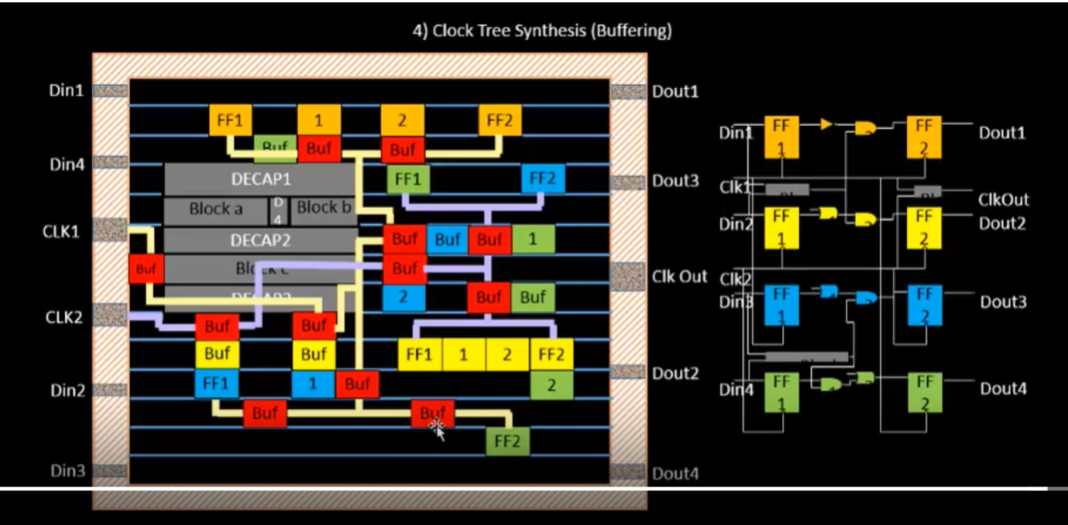

## Clock net shielding and cross talk.

Need to do clock net shielding to reduce the glitch and cross talk and decoupling with nearby net.

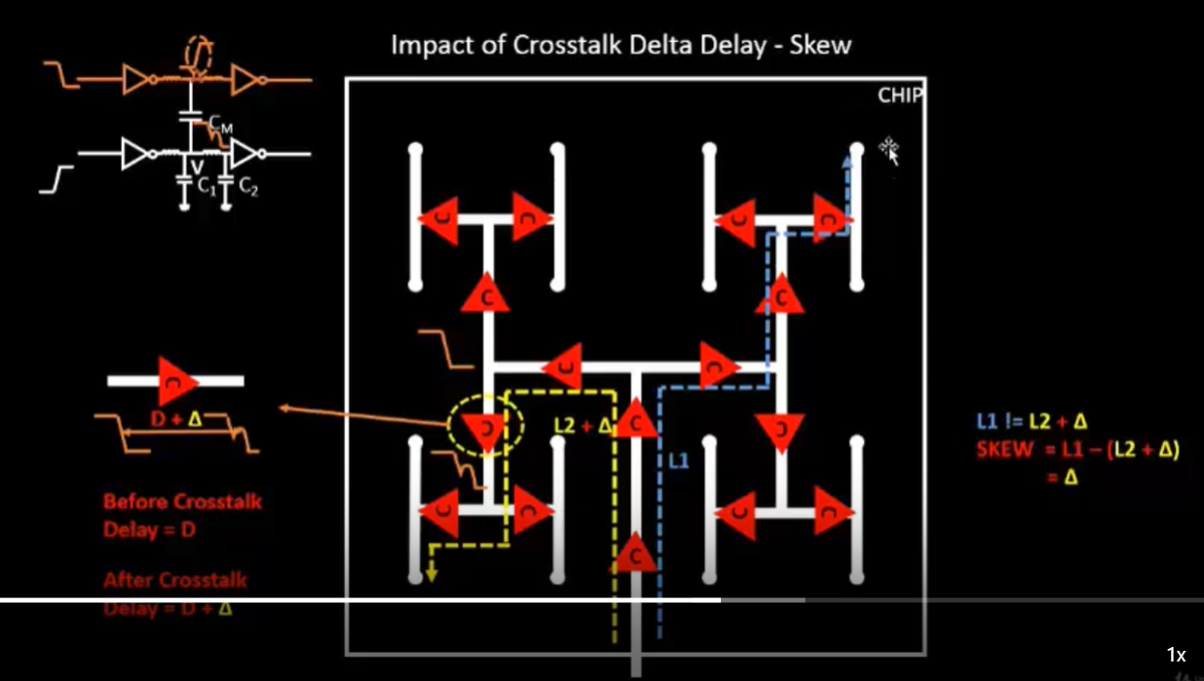 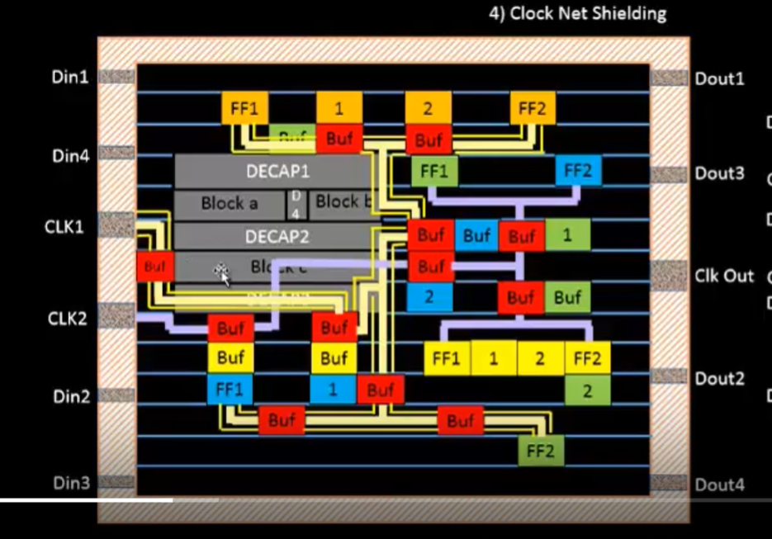

## Genrate verilog after doing the replacement of the cells and run synthesis again

**% write_verilog** /home/nawal.kishor/Desktop/work/tools/openlane_working_dir/openlane/designs/picorv32a/runs/09-07_05-15/results/synthesis/picorv32a.synthesis.v

*Checked inside the modified Verilog netlist and cell has been replaced successfully. Replaced cell name* ***_2 to _4***

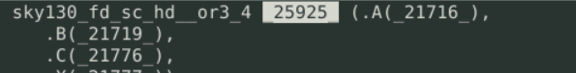

## Run floorplan and placement with using modified Verilog netlist

Command used :

init_floorplan

place_io

global_placement

tap_decap_or

detailed_placement

## Run CTS with using modified Verilog and after CTS new Verilog netlist DEF files has been created , Analysis the results

1. Repeaters buffers are added into the netlist and added information in Verilog and def files.



1. Command executed in running cts **:**

proc run_cts {args} {

if { ! [info exists ::env(CLOCK_PORT)] && ! [info exists ::env(CLOCK_NET)] } {

puts_info "::env(CLOCK_PORT) is not set"

puts_warn "Skipping CTS..."

set ::env(CLOCK_TREE_SYNTH) 0

}

if {$::env(CLOCK_TREE_SYNTH)} {

puts_info "Running TritonCTS..."

set ::env(CURRENT_STAGE) cts

TIMER::timer_start

if { ! [info exists ::env(CLOCK_NET)] } {

set ::env(CLOCK_NET) $::env(CLOCK_PORT)

}

set ::env(SAVE_DEF) $::env(cts_result_file_tag).def

set report_tag_holder $::env(cts_report_file_tag)

set ::env(cts_report_file_tag) [ index_file $::env(cts_report_file_tag) ]

# trim the lib to exclude cells with drc errors

if { ! [info exists ::env(LIB_CTS) ] } {

set ::env(LIB_CTS) $::env(TMP_DIR)/cts.lib

trim_lib -input $::env(LIB_SYNTH_COMPLETE) -output $::env(LIB_CTS) -drc_exclude_only

}

try_catch openroad -exit $::env(SCRIPTS_DIR)/openroad/or_cts.tcl |& tee $::env(TERMINAL_OUTPUT) [index_file $::env(cts_log_file_tag).log 0]

check_cts_clock_nets

set ::env(cts_report_file_tag) $report_tag_holder

TIMER::timer_stop

exec echo "[TIMER::get_runtime]" >> [index_file $::env(cts_log_file_tag)_runtime.txt 0]

set_def $::env(SAVE_DEF)

write_verilog $::env(yosys_result_file_tag)_cts.v

set_netlist $::env(yosys_result_file_tag)_cts.v

Openroad tool only runs floorplan, placement CTS routing that is why we have only these tcl files inside the directory Openroad :



***% echo $::env(LIB_FASTEST)***

*/openLANE_flow/designs/picorv32a/src/sky130_fd_sc_hd__fast.lib*

***% echo $::env(LIB_CTS)***

*/openLANE_flow/designs/picorv32a/runs/09-07_05-15/tmp/cts.lib*

***% echo $::env(CURRENT_NETLIST****)*

*/openLANE_flow/designs/picorv32a/runs/09-07_05-15/results/synthesis/picorv32a.synthesis_cts.v*

***% echo $::env(CURRENT_DEF)***

*/openLANE_flow/designs/picorv32a/runs/09-07_05-15/results/cts/picorv32a.cts.def*

***% echo $::env(CTS_MAX_CAP)***

*1.53169*

***% echo $::env(CTS_CLK_BUFFER_LIST)***

*sky130_fd_sc_hd__clkbuf_1 sky130_fd_sc_hd__clkbuf_2 sky130_fd_sc_hd__clkbuf_4 sky130_fd_sc_hd__clkbuf_8*

***% echo $::env(CTS_ROOT_BUFFER)***

*sky130_fd_sc_hd__clkbuf_16 -🡪* ***Max cap is at output of this buffer***

## Setup timing analysis using real clocks

1. Inside the real clock network, we would have multiple clock buffers and inverters.
2. Here [delta1=delay of buffer 1,2] [delta2= delay of buffer 1,2,3,4] [skew=delta2-delta1]
3. Slack = Data required time -Data arrival time

**Skew and Slack**, **Hold analysis**  
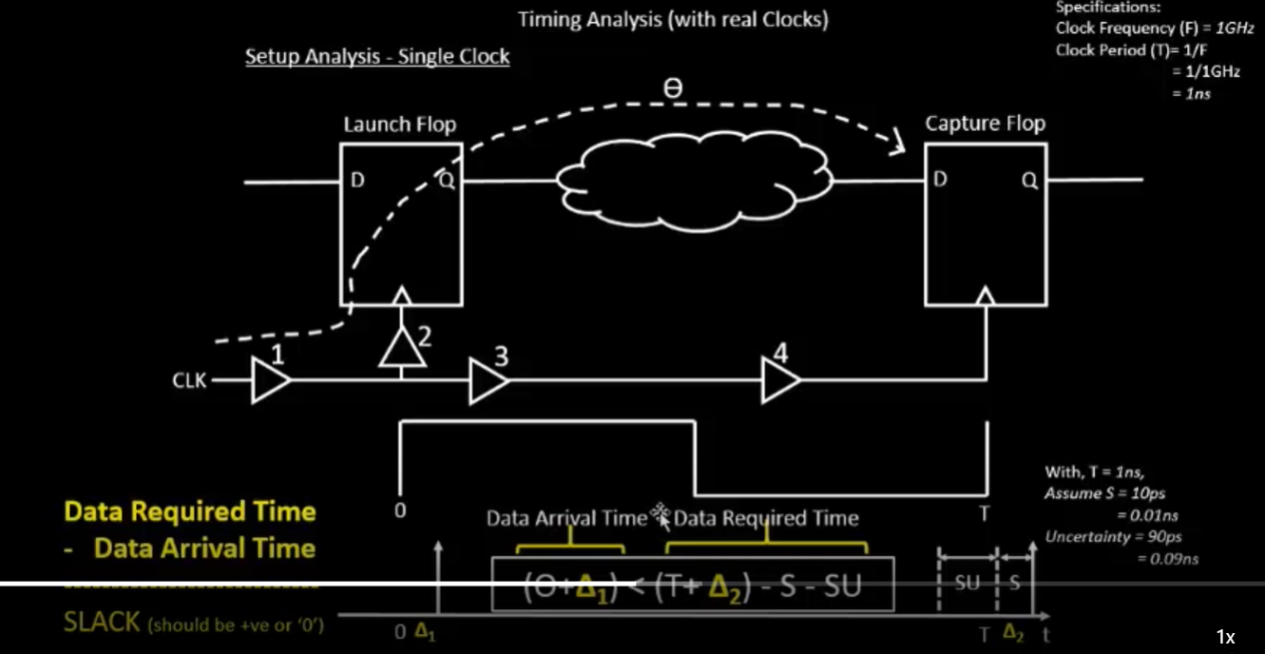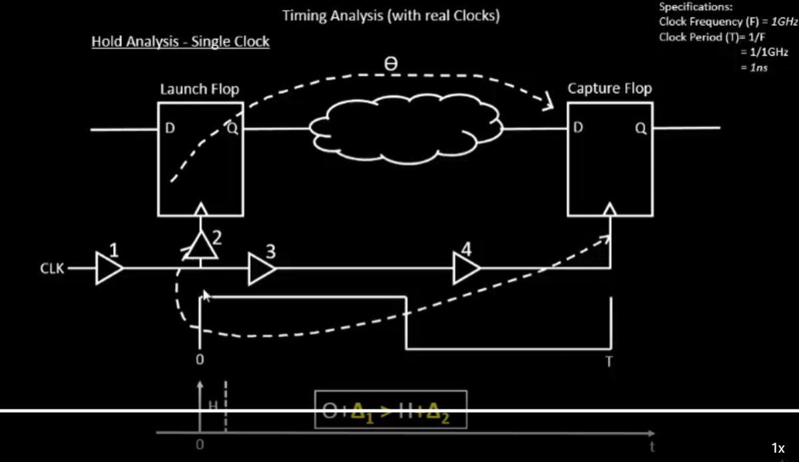

## Post CTS analysis in tool openroad:

Command used:

|  |
| --- |
| % openroad  % read_lef designs/picorv32a/runs/09-07_05-15/tmp/merged.lef  % read_def designs/picorv32a/runs/09-07_05-15/results/cts/picorv32a.cts.def  % write_db pico_cts.db  % read_db pico_cts.db  % read_verilog designs/picorv32a/runs/09-07_05-15/results/synthesis/picorv32a.synthesis_cts.v  % read_liberty -max designs/picorv32a/src/sky130_fd_sc_hd__slow.lib  % read_liberty -min designs/picorv32a/src/sky130_fd_sc_hd__fast.lib  % read_sdc designs/picorv32a/src/my_base.sdc  % set_propagated_clock [all_clocks]  % report_checks -path_delay min_max -format full_clock_expanded -digits 4  **While using the typical.lib**  % read_liberty designs/picorv32a/src/sky130_fd_sc_hd__typical.lib  % echo $::env(CURRENT_DEF)  % set ::env(CURRENT_DEF) placement/picorv32a.placement.def |

## Setup and hold before editing the list: CTS_CLK_BUFFER_LIST

% echo $::env(CTS_CLK_BUFFER_LIST)

sky130_fd_sc_hd__clkbuf_1 sky130_fd_sc_hd__clkbuf_2 sky130_fd_sc_hd__clkbuf_4 sky130_fd_sc_hd__clkbuf_8

**setup and hold slack values:**

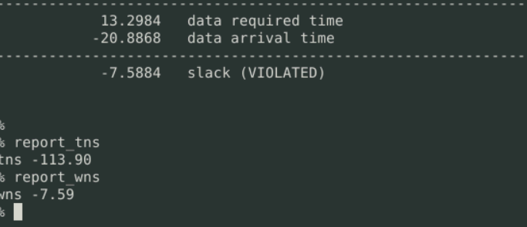

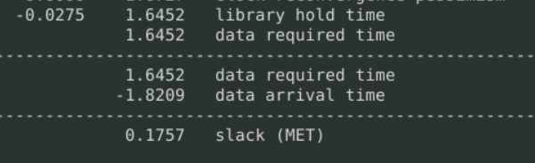

## **Setup and hold after editing the list: CTS_CLK_BUFFER_LIST**

CTS slacks after editing the CTS_CLK_BUFFER_LIST. Removed   
command used: set ::env(CTS_CLK_BUFFER_LIST) [lreplace $::env(CTS_CLK_BUFFER_LIST) 0 0]

% echo $::env(CTS_CLK_BUFFER_LIST)

sky130_fd_sc_hd__clkbuf_2 sky130_fd_sc_hd__clkbuf_4 sky130_fd_sc_hd__clkbuf_8

**Setup slack -7.5192 slack (VIOLATED)**

**Hold slack 0.2995 slack (MET)**

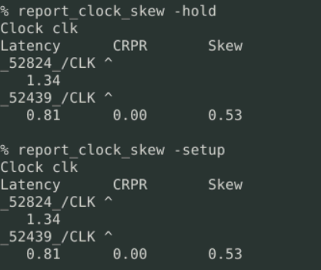

## Insert the buffer in list CTS_CLK_BUFFER_LIST

% set ::env(CTS_CLK_BUFFER_LIST) [linsert $::env(CTS_CLK_BUFFER_LIST) 0 sky130_fd_sc_hd__clkbuf_1 ]

sky130_fd_sc_hd__clkbuf_1 sky130_fd_sc_hd__clkbuf_2 sky130_fd_sc_hd__clkbuf_4 sky130_fd_sc_hd__clkbuf_8

# Build power distribution network

Command used : run_pdn

Power distribution network for standard cell and Macro cells inside the design

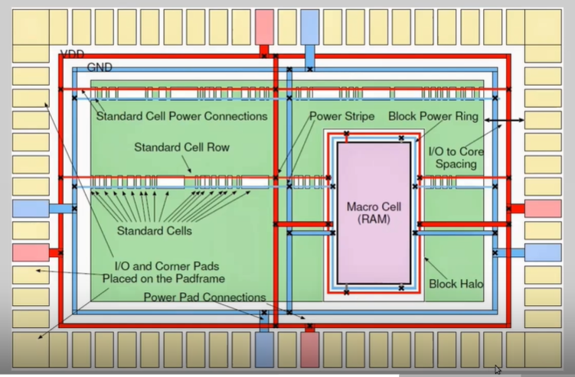

# Run routing

Command used: run_routing

It takes pdn.def file for the routing.

## Final outputs after run routing :

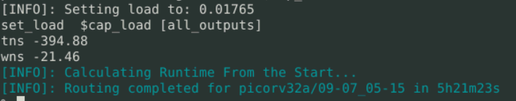

## Two steps for the routing

1. Fast routing -routed region divided into rectangular grids. It also called global route. Creates 3D routing graphs.
2. Detailed routing : it is done by the tritonRoute . realized the segments and via according to the global routing.

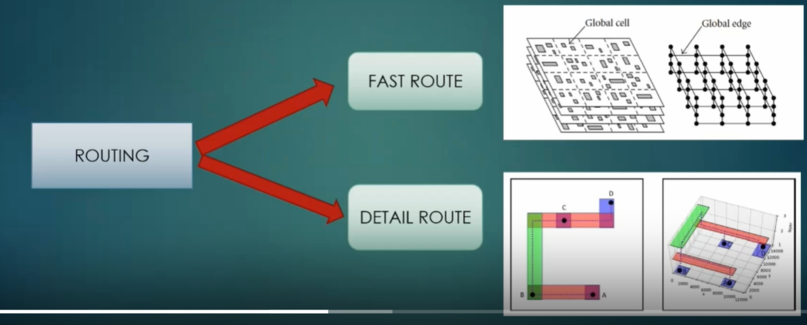

## Feature of the TritonRoute

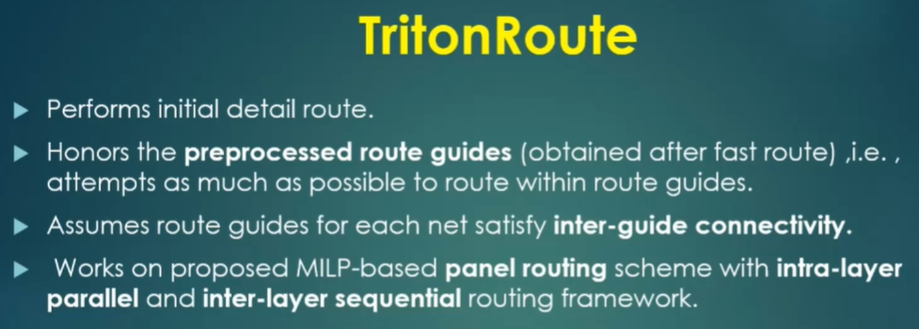

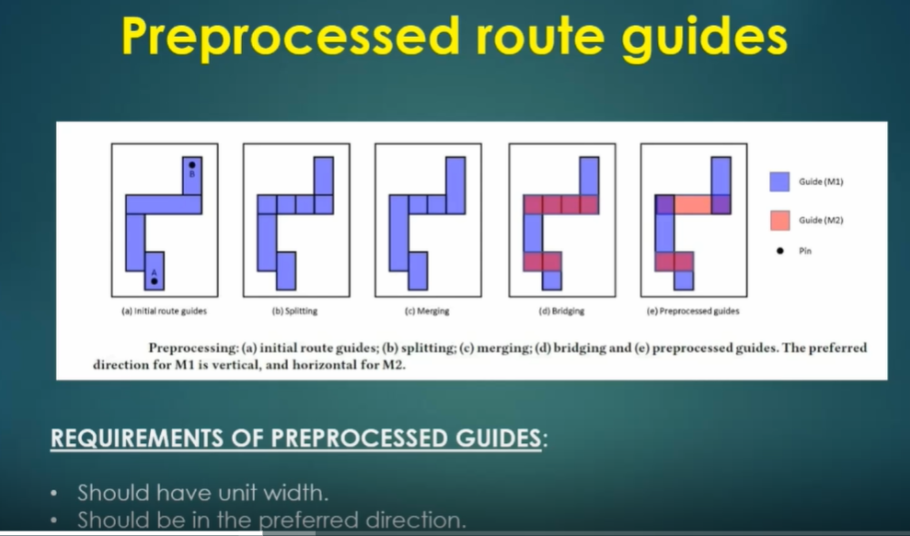

## Inter-guide connectivity

1. Two guides are connected if they are on the same metal layer with touching adges
2. Neighboring metal layers with non-zero vertical overlap area

## Problems statement:

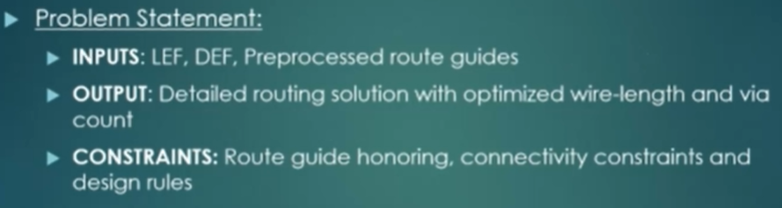

## How to handle connectivity:

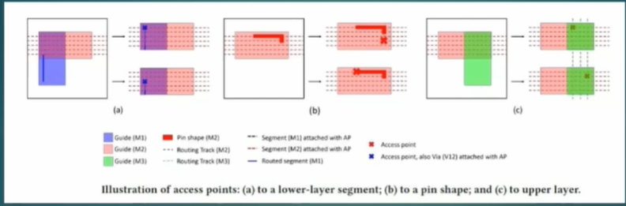

1. Access point AP: on-grid point on the metal layer of the route guide . and it is used to connect the lower layer and upper layer segments, pins, and IO ports.
2. Access point cluster APC: A union of all APS same lower layer segment and upper layer guide, pins an io ports

## Final file list post-route

1. Checked memory required: it is less

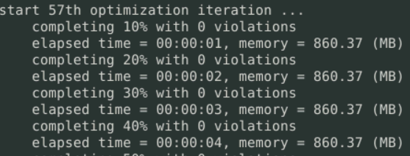

number of violations = 0 -> number of violations is zero because we used the strategy is zero

fast routing guide inside the tmp/routing dir : here metal layers associated with rectangle co-ordinates and _00000_ it’s a net and have a rectangular shapes defined for every nets.

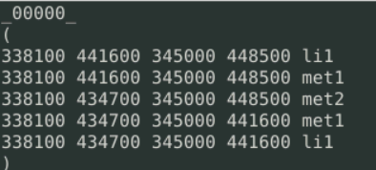

## Post route STA Analysis

Spef file has been created by default in the routing dir :

designs/picorv32a/runs/09-07_05-15/results/routing/picorv32a.spef

**Verilog files are created**

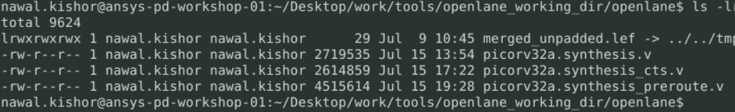

Using these extra files, we can run the STA after routing also.